DOCKETING THE CHAPTER 13 PLAN, EFFECTIVE 12/1/17
Filer must select at least one checkbox.
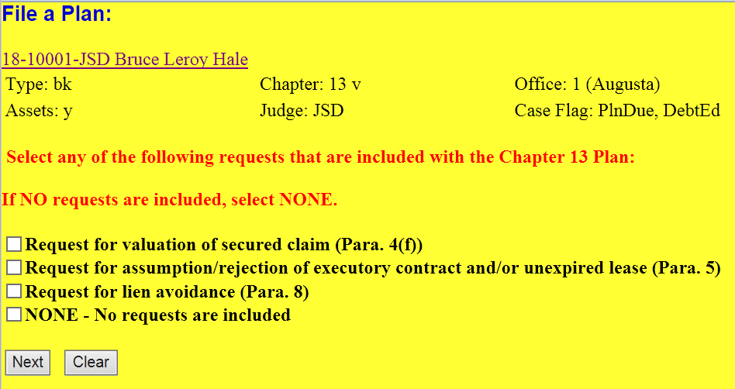
Filer cannot proceed without making a selection.
Depending on the selections made above, the following screens will appear. The filer must enter the number of requests included in the plan (e.g., number of liens to be avoided).
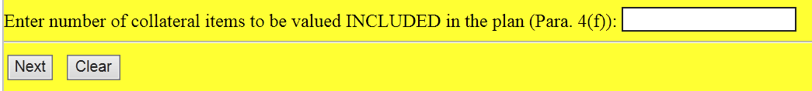
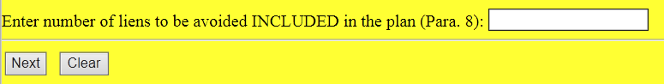
Filer cannot proceed without making an entry.
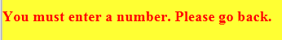
Filer must then answer a YN question concerning whether or not a COS is included. Select YES, and the docket text populates “with Certificate of Service attached.” Select NO, and the text entry reads “without Certificate of Service attached.” If a notice provider is being used, the docket text populates “without Certificate of Service attached. (Use of notice provider indicated).”

Filer cannot proceed thru this screen without making a selection.

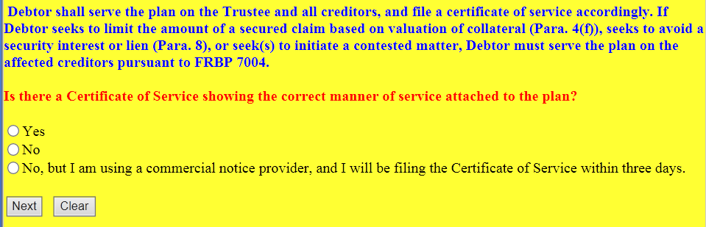
FINAL DOCKET TEXT SAMPLES

COS attached:

No COS attached:
Use of a commercial notice provider indicated:

DOCKETING AN AMENDED CHAPTER 13 PLAN BEFORE CONFIRMATION, EFFECTIVE 12/1/17

Relate the amended plan to the previously filed plan.

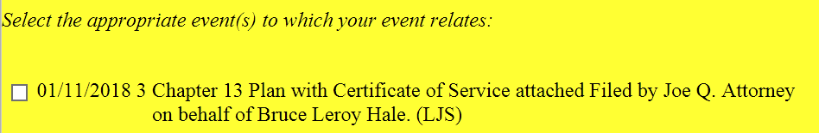

Select any NEW requests. If you ARE NOT including new requests, select the NONE checkbox.

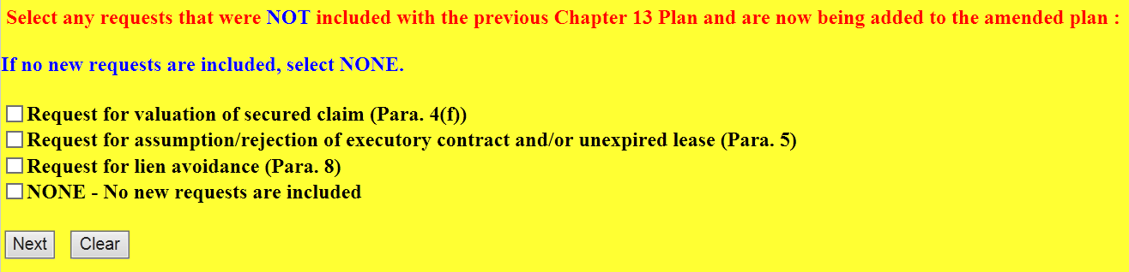

Filer cannot proceed without making a selection.
Depending on the selections made above, the following screens will appear. The filer must enter the number of requests included in the plan (e.g., number of liens to be avoided).

Filer cannot proceed without making an entry.
Filer must then answer a YN question concerning whether or not a COS is included. Select YES, and the docket text populates “with Certificate of Service attached.” Select NO, and the text entry reads “without Certificate of Service attached.” If a notice provider is being used, the docket text populates “without Certificate of Service attached. (Use of notice provider indicated).”

Filer cannot proceed thru this screen without making a selection.

FINAL DOCKET TEXT SAMPLES

COS attached:

No COS attached:
Use of a commercial notice provider indicated:

